1. **Introduction:** 
   1. **Project Overview**

A Daily Expense Tracker is a one kind of digital diary that helps to keep an eye on all of our money related transitions and also provides all financial activities report daily, weekly, monthly and yearly. Users get notification to record expenses and incomes that are helpful to the tracking system of the application. All information is saved in offline mode so users can easily access any time and any palaces. The User interface of the Daily Expense Tracker is basic and attractive so it is easy to understand and the best way to record our financial data. A Daily Expense Tracker is a one kind of digital diary that helps to keep an eye on all of our money related transitions and also provides all financial activities report daily, weekly, monthly and yearly. Users get notification to record expenses and incomes that are helpful to the tracking system of the application. All information is saved in offline mode so users can easily access anytime and any palaces. User interface of the Daily Expense Tracker is very simple and attractive so it is easy to understand and the best way to record our financial data.

A Personal Expense Tracker is a one kind of digital diary that helps to keep an eye on all of our money related transitions and also provides all financial activities report daily, weekly, monthly and yearly. Users get notification to record expenses and incomes that are helpful to the tracking system of the application. All information is saved in shown so users can easily access any time and any palaces. User interface of the Daily Expense Tracker is very simple and attractive so it is easy to understand and the best way to record our financial data. Personal Expense tracker provides analysis graph of overall expenditure done on the commodities and other things. The analysis graph provides a comparison of the income earned in that month and also provides expenditure made in higher rate for any particulars. It is also made of such design that will gives the use a popup alert when the expenses go higher than the level that the user fixed. The alarm will help the user control the expenses for the period.

* 1. **Purpose:**

This project is based on an expense and income tracking system. This project aims to create an easy, faster and smooth tracking system between the expense and the income. This project also offers some opportunities that will help the user to sustain all financial activities like digital automated diary. So, for the better expense tracking system, we developed our project that will help the users a lot. Most of the people cannot track their expenses and income one way they face a money crisis, in this case Income expense tracker can help the people to track income-expense day to day and making life tension free. Money is the most valuable portion of our daily life and without money we will not last one day on the earth. So, using the Income expense tracker application is important to load a happy family. Income expense tracker helps the user to avoid unexpected expenses and bad financial situations. This Project will save time and provide a responsible lifestyle. This system is made and supervised by the experts and satisfying by the user.

1. **LITERATURE SURVEY:**
   1. **Existing problem**

All the personal expense tracker application are in the offline so they can able to use it any where without the internet if they mistakenly delete the application or if they miss their phone, they can’t able to view the expenses. It is one of the major drawbacks. And also, there is lot of chances for delete their expenses unknowingly. Ans also there is no good-looking user interface in some application and also it is hard to use by the old people. In some application they don’t have an oauth facility which means anyone can able to view their expenses.

* 1. **References**

|  |  |  |  |
| --- | --- | --- | --- |
| **Name of Application** | **Function** | **Features** | **Cons** |
| Wallet | The Wallet app is a personal expense tracker application that comes loaded with a ton of features, coupled with a beautiful interface and great customer support. | It's simple to keep track of where your money is going with a wallet. The software will provide you insights into your spending patterns via graphs and visualizations when you link your bank accounts to it. Additionally, you may establish savings objectives, which the app will aid in achieving. Was It Worth It is a wonderful tool that calculates a score for your most recent purchases. Although it is free to download the Android and iOS versions, some of the best features need a membership. | * Data security.      * Data security.      * It is incompatible with some credit cards. |
| Mint | It is a no-cost, user-friendly budgeting programmed that offers automated and individualized categorization of downloaded transactions as well as other useful spending monitoring capabilities. | Users of Mint may create personalized budgets, keep tabs on their spending, set any required bill-paying reminders, check their credit score, and see how their assets are doing. As soon as a person logs in, their financial information is instantly updated, and previous transactions are automatically categorized into either already-existing or newly-created groups. | * Is not compatible with numerous currencies.      * No ability to pay bills. |
| AndroMoney | AndroMoney is a mobile phone personal financial application. This tool will help us manage our money more effectively. | support for multiple accounts, account transfers, and account balances. Online Storage. Device synchronization. Calculating number pad - Custom attribute-based hierarchical categories. Cash Flow Trend, Pie, and Bar Charts. Password Protection. View your cost and income summary. Save data backups to Excel or Mac Number. | * Database synchronization error      * Unintuitive UI |

* + - **Wallet:** [Wallet Application Link](https://play.google.com/store/apps/details?id=com.droid4you.application.wallet&hl=en_IN&gl=US)
    - **Mint:** [Mint Application Link](https://play.google.com/store/apps/details?id=com.mint&hl=en_IN&gl=US)
    - **AndroMoney:** [AndroMoney Application Link](https://play.google.com/store/apps/details?id=com.kpmoney.android&hl=en_IN&gl=US)
    - **Walnut:** [Walnut Application Link](http://app.getwalnut.com/)

**c. Problem Statement Definition**

A system for tracking expenses and income is the foundation of this project. The goal of this project is to provide a simple, quick, and seamless tracking system between expenses and revenues. Additionally, this technology provides opportunities like a digital automated diary that will enable the user to maintain all financial operations. Therefore, we created our project, which will greatly assist the users, in order to create a better spending monitoring system. Most people struggle with money problems because they are unable to keep track of their income and costs. In this situation, an income expense tracker can assist people in keeping track of their income and expenses on a daily basis and reducing stress. We cannot survive on earth for even a single day without money, which is the most valuable aspect of our daily lives. Therefore, employing the Income expense tracker tool is crucial for a content family. The user of an income expense tracker might avoid unforeseen costs and difficult financial situations. Time will be saved and a responsible lifestyle will be offered through this project. This system was created, is under the supervision of specialists, and is user-satisfying.

1. **IDEATION & PROPOSED SOLUTION**
   1. **Empathy Map Canvas**

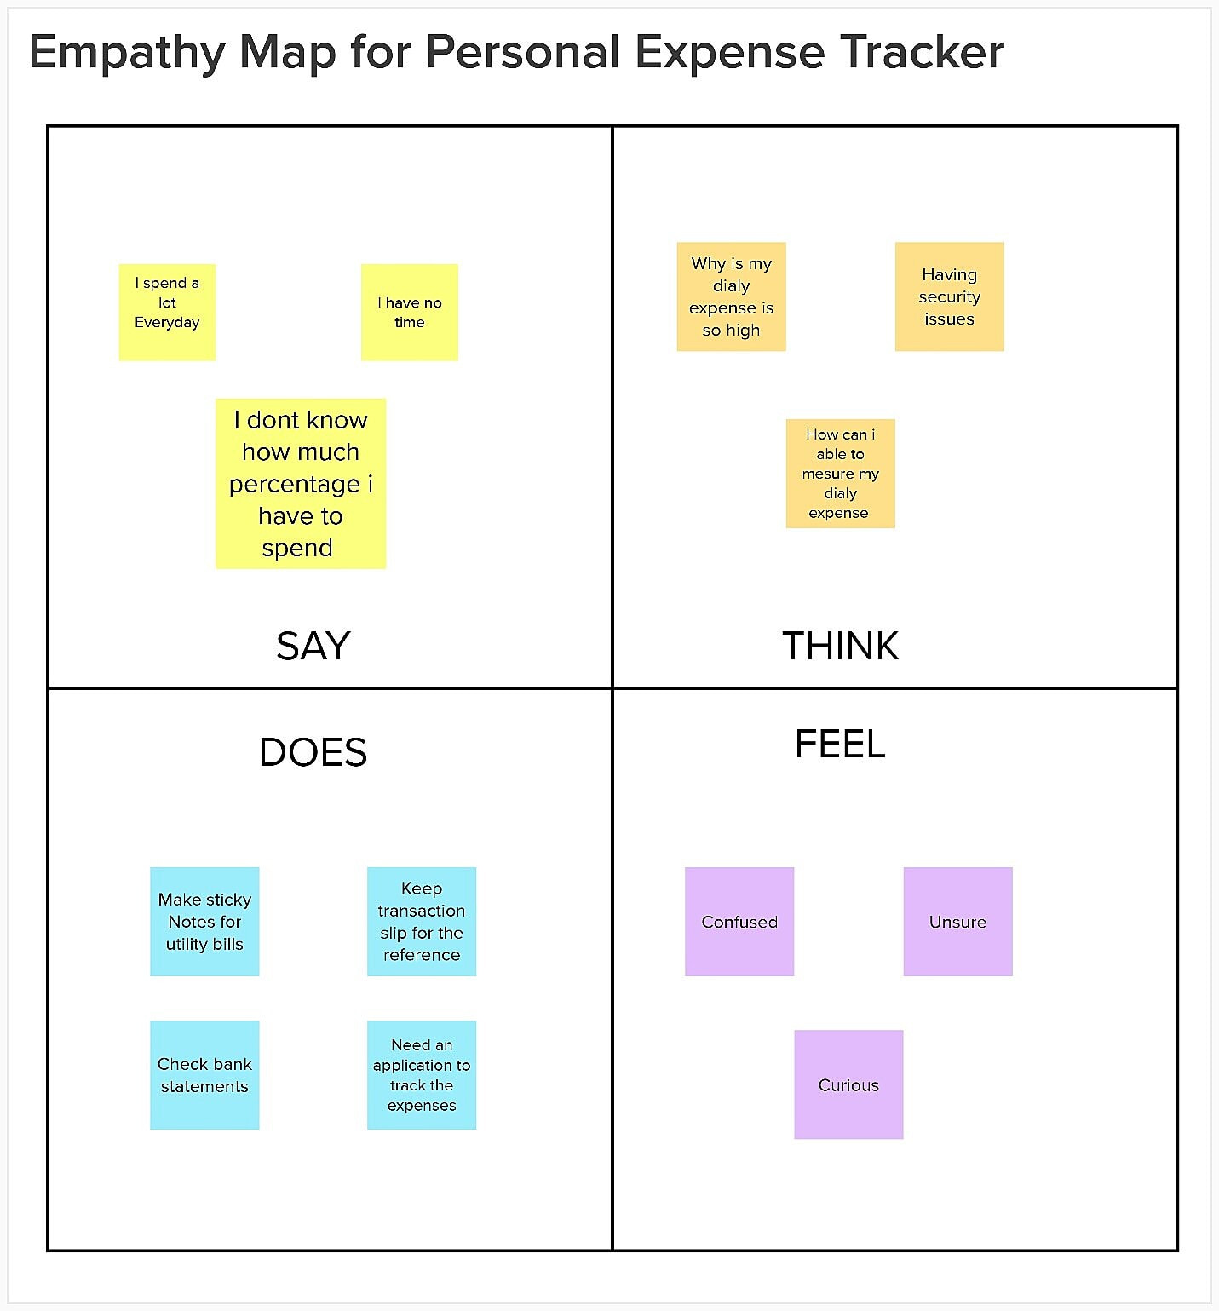

* 1. **Ideation & Brainstorming**

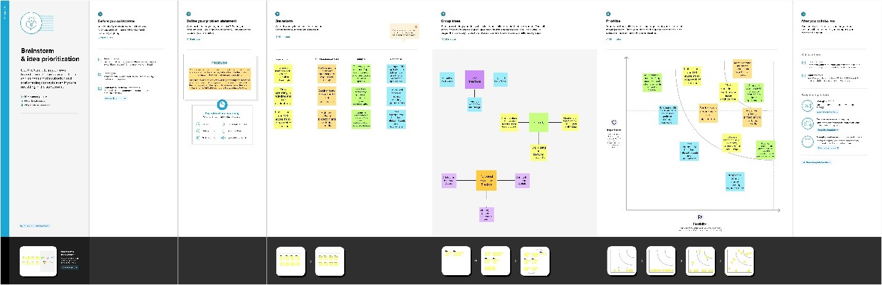

* 1. **Proposed Solution**

|  |  |  |
| --- | --- | --- |
| **S.No.** | **Parameter** | **Description** |
|  | Problem Statement (Problem to be solved) | It is difficult to manage the monthly Expense in the paper form. And also, the paper/hand written may be lost. |
|  | Idea / Solution description | Application designed to use by the large-scale people with the small or large amount of data. And also give the graphical representation. It gives the alert when the expense is over the budget. Generate the Expense report to make their tracking. When the user sees the graphical representation, it will be easy for the user to understand. |
|  | Novelty / Uniqueness | User gets notify when the expense is exceeds the budget threw the main or SMS to the registered email/phone. |
|  | Social Impact / Customer Satisfaction | The programmer should be able to produce reports on users' spending and alert them when they go over their budget. In order to create the forecast, it is intended to be dynamic. Additionally, it offers users' personal data, their earnings, and their spending. This programmer can educate regular people about money and other topics.  Additionally, this software supports user financial responsibility. As opposed to manually inputting information, it saves time. |
|  | Business Model (Revenue Model) | This application is offered without charge. However, there will be some advertising. The premium edition has extra features and is free of advertisements. |
|  | Scalability of the Solution | This programmer has the performance and security to manage a huge number of users and data. This programmer may be configured for both large- and small-scale uses. Simple to access on a variety of devices. |

* 1. **Problem Solution fit**

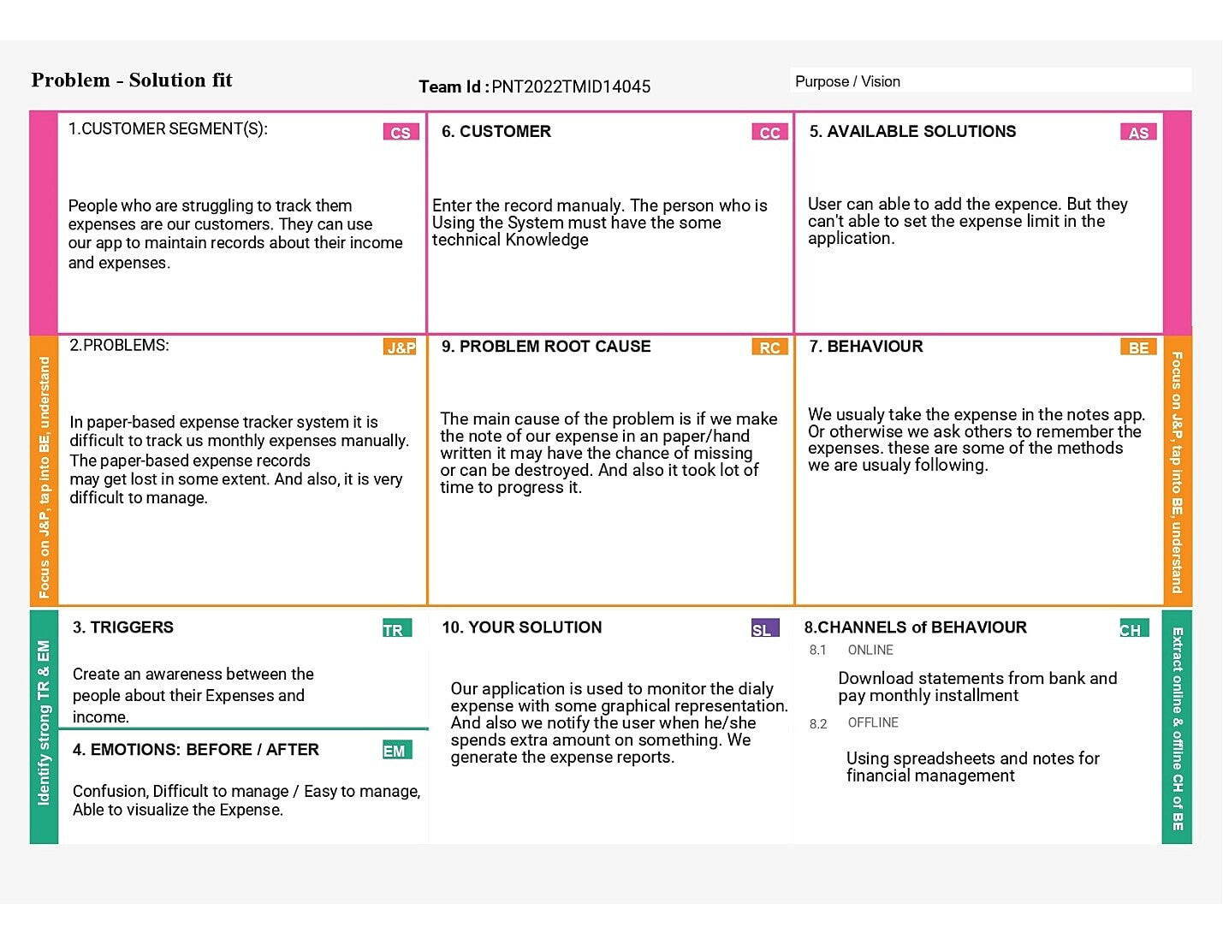

**Available Solution:** User can able to add expense. But they can’t able to set the limit of their expenses in their application.

**Problem root cause:** The main cause of the problem is if we make the note of our expense in a paper it may have the chance of missing or can be destroyed. And also, it took lot of time to progress it.

**Customer Segment:** People who are struggling to track them expenses are our customers. They can use our app to maintain records about their income and expenses.

**Problem:** In paper-based expense tracker system it is difficult to track monthly expenses manually. The paper-based expenses records may get lost in some extent. And also, it is very difficult to manage.

**Triggers:** Create an awareness between the people about their expenses and income.

**Emotions:** Confusion, difficult to manage/ easy to manage, able to visualize the expense.

**Customer:** Enter the record manually. The person who is using the system must have the same technical knowledge.

1. **REQUIREMENT ANALYSIS:**
   1. **Functional requirement**

These are the requirements that the end user specifically demands as basic facilities that the system should offer. All these functionalities need to be necessarily incorporated into the system as a part of the contract. These are represented or stated in the form of input to be given to the system, the operation performed and the output expected. They are the requirements stated by the user which one can see directly in the final product, unlike the non-functional requirements.

Following are the functional requirements of the proposed solution.

|  |  |  |
| --- | --- | --- |
| **FR No.** | **Functional Requirement (Epic)** | **Sub Requirement (Story / Sub-Task)** |
| FR-1 | User Registration | Registration through Form  Registration through Gmail  Registration through Email Account |
| FR-2 | User Confirmation | Confirmation via Email |
| FR-3 | Calendar | Personal expense tracker application must allow user to add the data to their expenses. |
| FR-4 | Graphical Representation | This application should graphically represent the expense in the form of report. |
| FR-5 | Report Generation | Graphical representation of report must be generated. |
| FR-6 | Category | This application shall allow users to add categories of their expenses. |

* 1. **Non-Functional requirements**

These are the quality constraints that the system must satisfy according to the project contract. The priority or extent to which these factors are implemented varies from one project to other. They are also called non-behavioral requirements.

Following are the non-functional requirements of the proposed solution.

|  |  |  |
| --- | --- | --- |
| **FR No.** | **Non-Functional Requirement** | **Description** |
| NFR-1 | **Usability** | Helps to keep an accurate record and track of their income and expenses easily. |
| NFR-2 | **Security** | We save the password in the encrypted form so it will add more secure to the application user. |
| NFR-3 | **Reliability** | Each data record is stored on a well-built efficient database schema. There is no risk of data loss. |
| NFR-4 | **Performance** | Expense kinds include categories and an option. The system's throughput is boosted because to the lightweight database support. |
| NFR-5 | **Availability** | User can able to access the application with the help of the internet throw the web browser. |
| NFR-6 | **Scalability** | The ability to appropriately handle increasing demands. |

1. **PROJECT DESIGN**
   1. **Data Flow Diagrams**

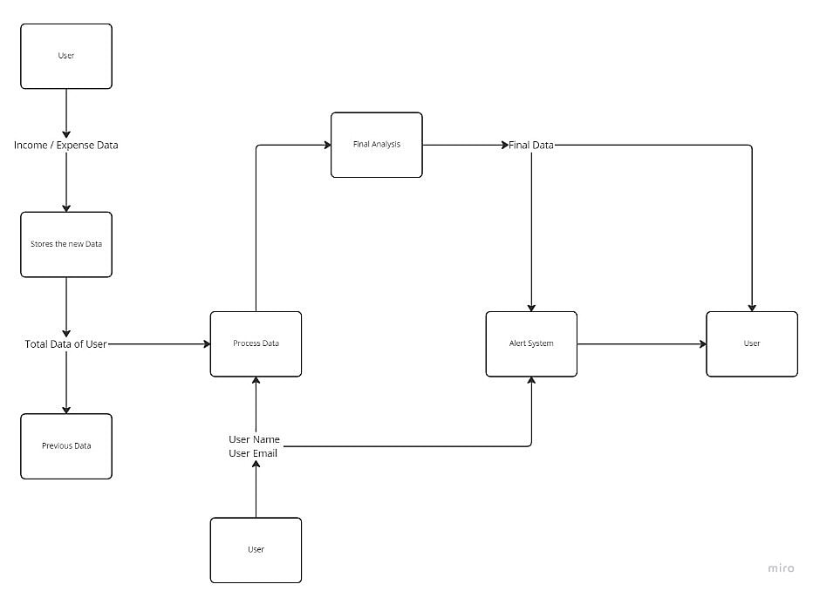

* 1. **Solution & Technical Architecture**

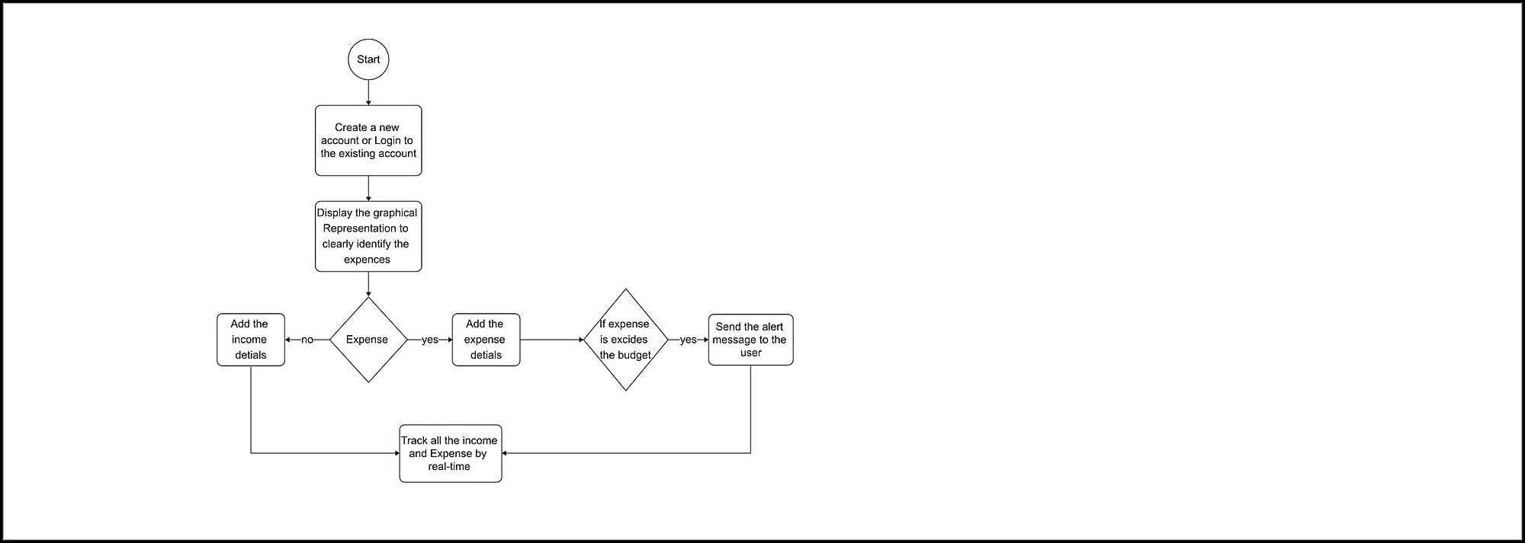

* 1. **User Stories**
     1. Rajesh, who is Shopaholic, he always tries hard to control the over expense. To stop him from overindulging in impulsive purchases, he must track his expense.

* + 1. Ram, who is interest in cryptocurrency. he always hard to find the expenses that he had previously invested currency. If there was an application to track the expense it helps him a lot.

* + 1. High school student Ramya often receives a little stipend from his parents. So, he can spend on both his normal bills and himself since he keeps track of his spending and uses smart budgeting techniques.

1. **PROJECT PLANNING & SCHEDULING**

**6.1 Sprint Plan & Estimation**

|  |  |  |  |  |  |  |
| --- | --- | --- | --- | --- | --- | --- |
| **Sprint** | **Functional Requirements (Epic)** | **User story number** | **User Story/ Task** | **Story Point** | **Priority** | **Team members** |
| S-1 | Login / signup | USN-1 | The login page allows a user to gain access to an application by entering their username and password | 20 | High | Rajeshkumar S  Ramachandramoorthy K B  Ramya S  Umapathi K |
| S-2 | Dashboard /  Profile | USN-2 | The user can use the dashboard as the visual display for the all kind of their data visualization | 20 | High | Rajeshkumar S  Ramachandramoorthy K B  Ramya S  Umapathi K |
| S-2 | Analysis page | USN-3 | The user can able to view the expense and income in the graphical representation | 20 | High | Rajeshkumar S  Ramachandramoorthy K B  Ramya S  Umapathi K |
| S-3 | Backend Works | USN-4 | All the back-end connectivity’s like send grid, chatbot, etc.…. | 20 | High | Rajeshkumar S  Ramachandramoorthy K B  Ramya S  Umapathi K |

* 1. **Sprint Delivery Schedule**

|  |  |  |  |  |  |
| --- | --- | --- | --- | --- | --- |
| **Sprint** | **Total Story Points** | **Duration** | **Sprint Start Date** | **End-**  **Date** | **Release Date** |
| S-1 | 20 | 6 Days | 24 Oct 2022 | 29 Oct 2022 | 29 Oct 2022 |
| S-2 | 20 | 6 Days | 31 Oct 2022 | 05 Nov 2022 | 05 Nov 2022 |
| S-3 | 20 | 6 Days | 07 Nov 2022 | 12 Nov 2022 | 12 Nov 2022 |
| S-4 | 20 | 6 Days | 14 Nov 2022 | 19 Nov 2022 | 1. Nov 2022 |

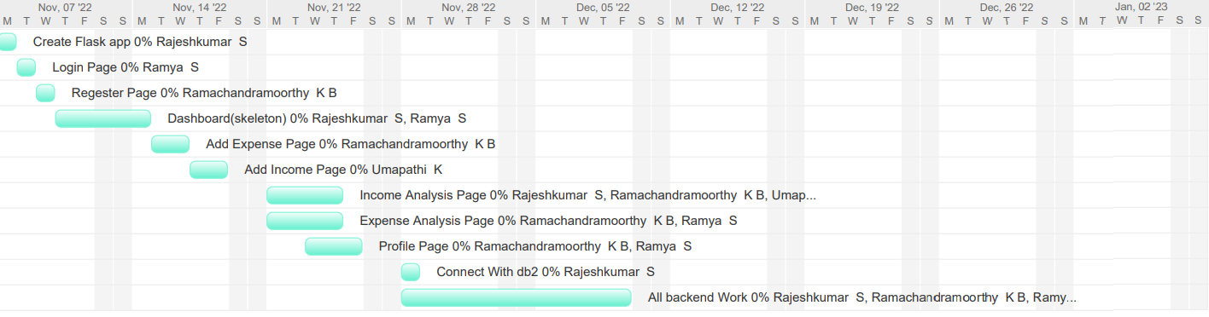

**7. CODING & SOLUTIONING (Explain the features added in the project along with code)**

**7.1 Feature 1**

We can able to analysis each expense and income between two dates. With the help of that graph, we can able to understand the income level easily and the expense level. And also, It is enchanting. Here we use the chart from the chart.js which is very easy to add it into your web page it and it will dynamically change the graph according to the data given to the graph.

**Code:**

<script>

va = '{{session["expensedatmth"]}}'

va = va.replaceAll('&#39;', '"')

metadata = JSON.parse(va)

// console.log(mthdata[mthdata.length-1])

document.getElementById('start_date').value = String(mthdata[0]);

document.getElementById('end_date').value = String(mthdata[mthdata.length - 1]);

// labels = '{{session["expensedate"]}}';

// labels = JSON.parse(labels)

datas = JSON.parse('{{session["expensevalue"]}}')

const data = {

labels: mthdata,

datasets: [{

label: 'Expenses',

data: datas,

backgroundColor: '#ff006f1c',

borderColor: '#FF006F',

pointBackgroundColor: '#FF006F',

pointHitRadius: '30',

fill: true,

tension: 0.3

}]

};

function filterData() {

const dates2 = [...mthdata];

// console.log(dates2);

const startdate = document.getElementById('start_date');

const enddate = document.getElementById('end_date');

// console.log(indexstartdate);

var startDate = new Date(startdate.value.toString());

var endDate = new Date(enddate.value.toString());

var resultProductData = dates2.filter(a => {

var date = new Date(a);

return (date >= startDate && date <= endDate);

});

// console.log(resultProductData)

const indexstartdate = dates2.indexOf(resultProductData[0]);

// console.log(startDate)

const indexenddate = dates2.indexOf(resultProductData[resultProductData.length-1]);

const filteredDate = dates2.slice(indexstartdate, indexenddate + 1);

const val = [...datas]

const filteredval = val.slice(indexstartdate, indexenddate + 1);

// console.log(indexenddate)

myChart.config.data.labels = filteredDate;

myChart.config.data.datasets[0].data = filteredval;

myChart.update();

}

const config = {

type: 'line',

data: data,

options: {

responsive: true,

maintainAspectRatio: false

}

};

const myChart = new Chart(

document.getElementById('myChart'),

config

);

</script>

**a.SendGrid**

SendGrid is a cloud-based SMTP solution that enables you to send email without the need for email servers. SendGrid handles all technical aspects, from infrastructure scalability to ISP outreach and reputation monitoring to whitelist services and real-time analytics. SendGrid offers two methods for sending email: via our SMTP relay or via our Web API. SendGrid offers client libraries in a variety of languages. This is the recommended method of integrating with SendGrid. If you prefer to use SendGrid without a client library, the Web API is recommended in most circumstances since it is quicker, has certain encoding benefits, and is generally easier to use. SMTP has numerous functions by default, but it is more difficult to set up.

**Web API**

* The Web API has some advantages over SMTP

* If your ISP blocks all outbound mail ports and your only option is HTTP.

* If there is high latency between your site and ours, the Web API might be quicker since it does not require as many messages between the client and server.

* If you do not control the application environment and cannot install and configure an SMTP library.

* If you build a library to send email, developing against a web API provides quicker development.

**SMTP Relay**

* If you are integrating SendGrid with an existing application, setting up the application to use our SMTP relay is easiest, as it only requires modifying SMTP configuration.

* Change your SMTP username and password to your SendGrid credentials.

* Set the server host name to smtp.sendgrid.net

* Use ports 25 or 587 for plain/TLS connections and port 465 for SSL connections.

**Code:**

import sendgrid

from sendgrid.helpers.mail import *

def mailtest_request(to_email):

sg = send grid.SendGridAPIClient(api_key= 'API_KEY' )

from_email = Email("to_email@gmail.com")

subject = "Budget Alert !"

content = Content("text/plain", "Your Expense is out of Budget !")

try:

mail = Mail(from_email, to_email, subject, content)

response = sg.client.mail.send.post(request_body=mail.get())

# print(response.status_code)

# print(response.body)

# print(response.headers)

print("Mail send Successfully !")

except:

print("Error While sending Mail !")

* 1. **Database Schema (if Applicable)**

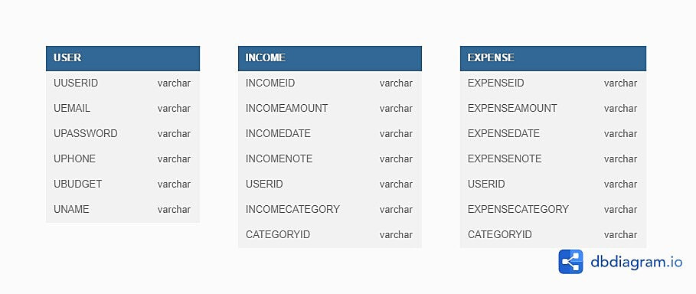

**USER Table:**

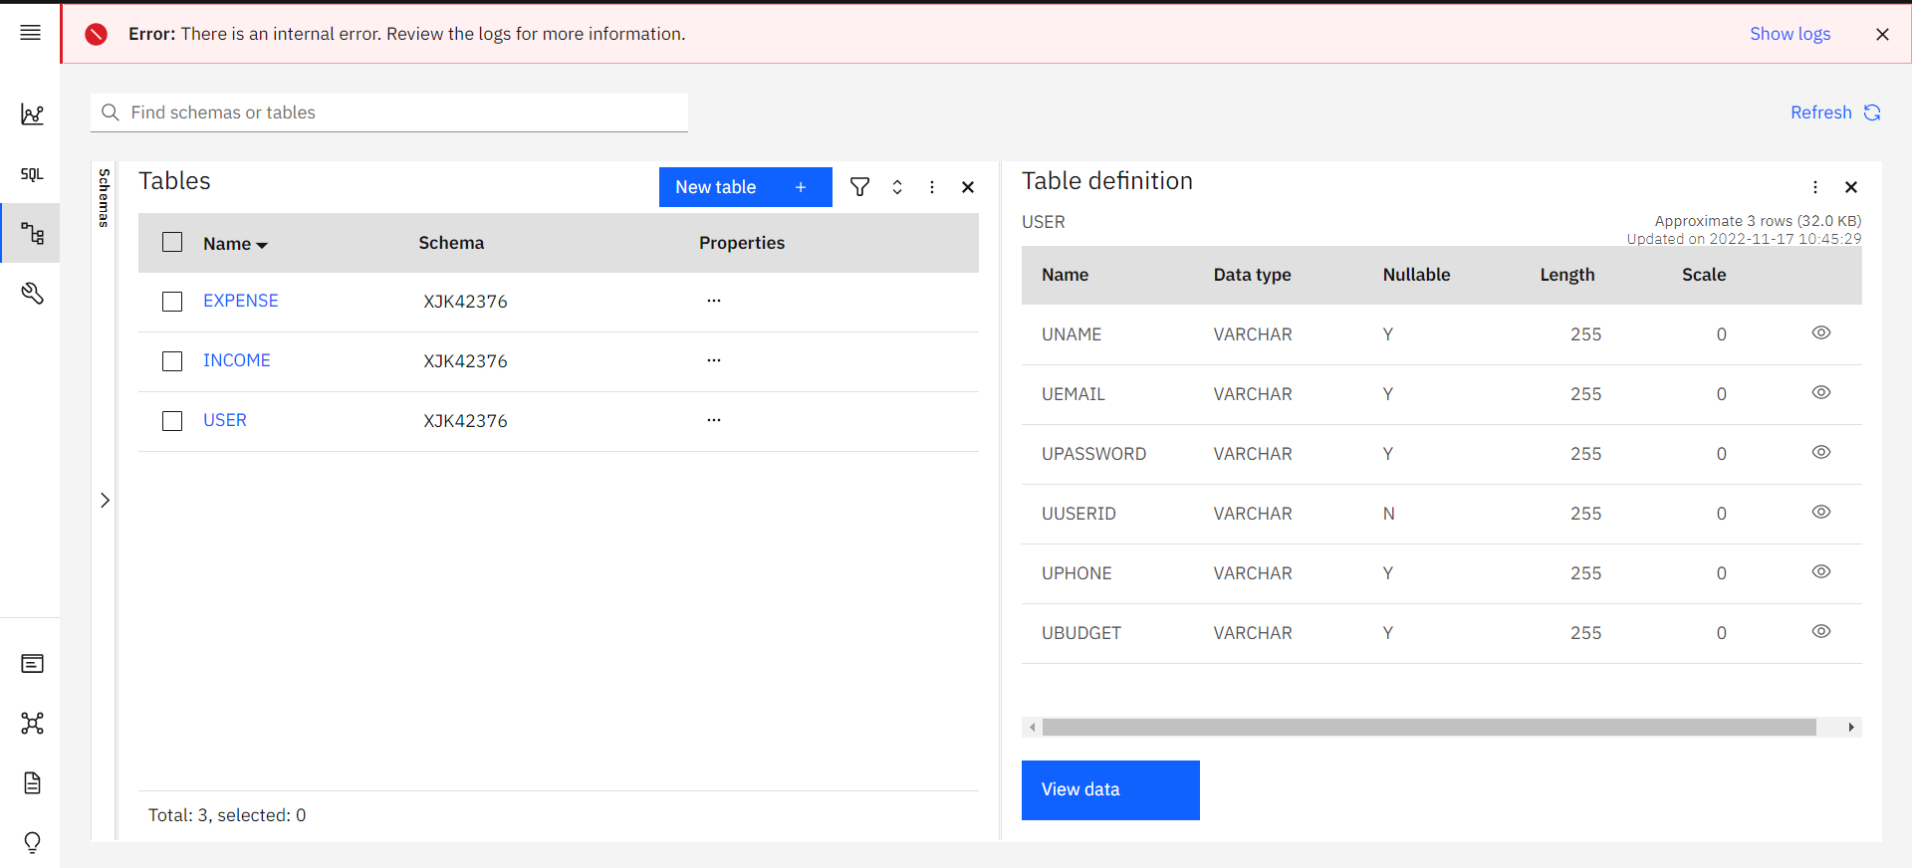

**INCOME Table:**

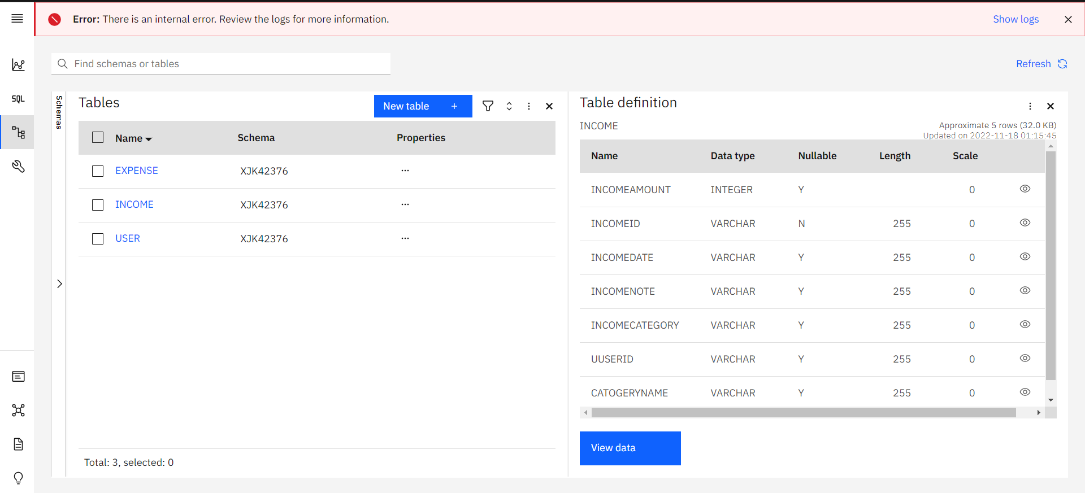

**EXPENSE Table:**

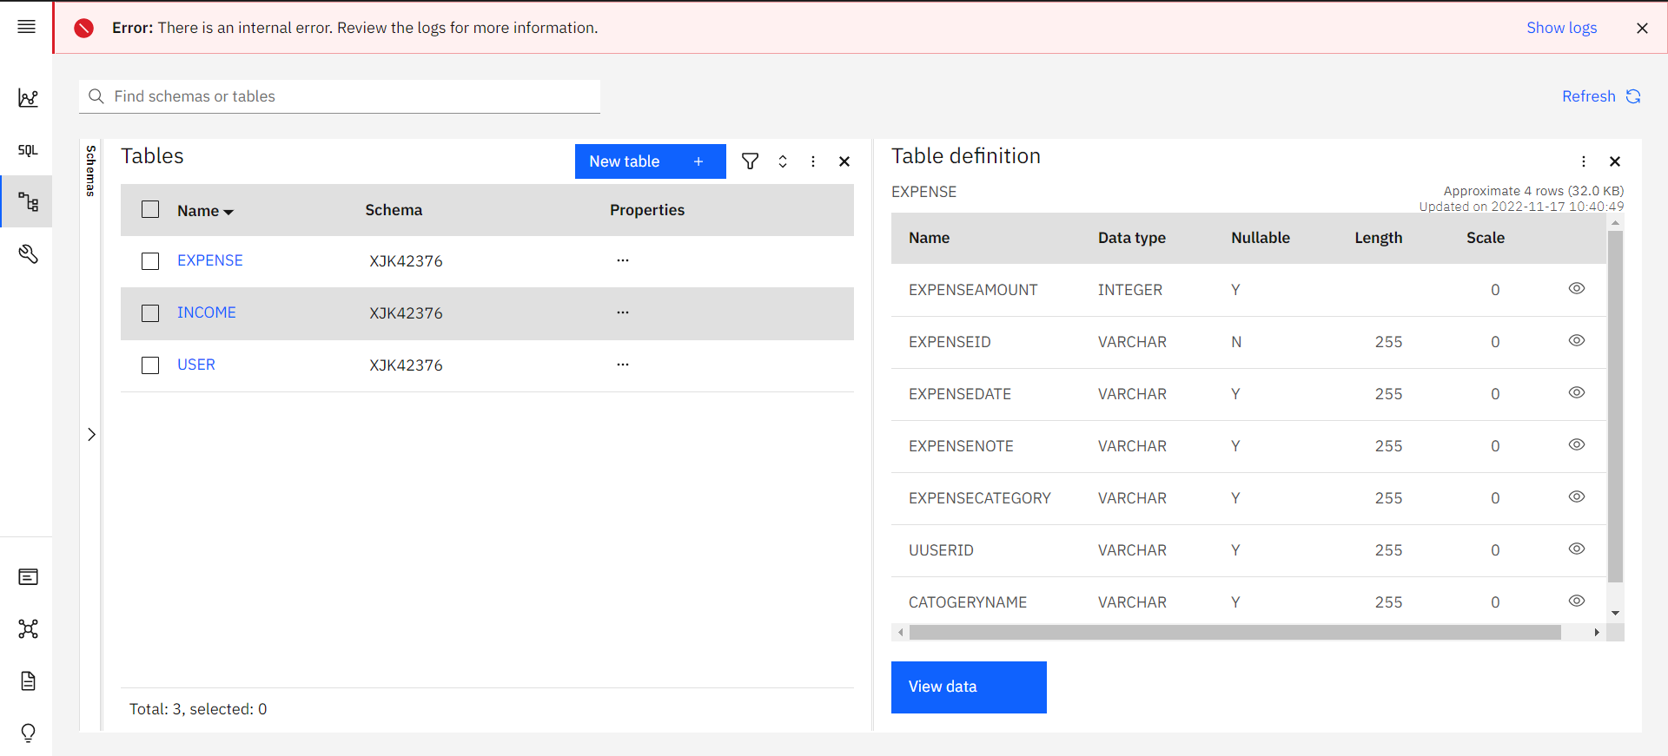

**8. TESTING**

|  |  |  |  |  |  |  |  |
| --- | --- | --- | --- | --- | --- | --- | --- |
| **TEST ID** | **FEATURE / MODEL** | **DESCRIPTION OF TASKS** | **CONDITION** | **EXPECTED RESULTS** | **RESULT** | **DEFECT / COMMENTS / ADDITIONS** | **BUGID** |
| 1 | Regester Page | A signup page (also known as a registration page) enables users and organizations to independently register and gain access to your system. It is common to have multiple signup pages depending on the types of people and organizations you want to register. | New User Regester | Enter their datas to the user Table | Pass | Everything is working Fine | Nil |
| Already Regestered User | Ask the user to log in | Pass | Nil |
| 2 | Login Page | The login page allows a user to gain access to an application by entering their username and password or by authenticating using a social media login. | If the entered email id and password match with the datat in the database. | Move to the dashboard | Pass | Working good | Nil |
| If the entered email id and password not match with any of the datat in the database. | show the error message | Pass | **Comments:** After the error message move the user to the login page. | Nil |
| 3 | Dashboard Page | Inthis dash board we can able to see the total expense , tota income and also the difference between the total expense and the total income. We can able to add the new income and new expence. And they able to see the expense list and the income list. | If the user is loged in. | Shows the data's that are related to that loged in user. | Pass | Working fine | Nil |
| 4 | Profile Page | In profile page we can able to view the user detials and they can able to edit their user detials except their email id. User can also able to update their budget. | User can able to edit the profile. | Change the Name, Phone, Password, Budget | Pass | **Comments:** After the update show the user that the update alert message not just the normal message at the top. | Nil |
| Click Logout Button | Clear the flask session variables and move to the login page | Pass |  | Nil |
| 5 | Income | In **Add Income** page we can able to add the income and able to describe their category and make the note. | On clicking the Add income button | Add the income to the Income table | Pass | **Comments:** Display alert message after the addition of detials to the table. | Nil |
| **List Income** page displayes the all the Income that are entered by the user. | On clicking the Show more button | We can able to go to the List Income page. Wich has all the income detials | Pass |  | Nil |
| **Edit Income** page is used to edit the datas that have entered earlier. | Onclick on the income card | After clicking the update button the datas that are enterd should be modified in the income table | Pass |  | Nill |
| 6 | Expense | In **Add Expense** page we can able to add the income and able to describe their category and make the note. | On clicking the Add iexpense button | Add the expense to the expense table | Pass | **Comments:** Display alert message after the addition of detials to the table. | Nil |
| **List Expense** page displayes the all the Income that are entered by the user. | On clicking the Show more button | We can able to go to the List expense page. Wich has all the expense detials | Pass |  | Nil |
| **Edit Expense** page is used to edit the datas that have entered earlier. | Onclick on the expense card | After clicking the update button the datas that are enterd should be modified in the expense table | Pass |  | Nill |
| 7 | Sendgrid | By using the sendgrid we can able to send the mail to the user. About the Expense is over the budget. |  | Mail to the user's regestered email | Pass |  | Nill |

* 1. **Acceptance Testing:**

**Purpose of Document**

The purpose of this document is to briefly explain the test coverage and open issues of the Personal Expense Tracker project at the time of the release to User Acceptance Testing (UAT).

**Defect Analysis**

This report shows the number of resolved or closed bugs at each severity level, and how they were resolved.

|  |  |  |  |  |  |
| --- | --- | --- | --- | --- | --- |
| **Resolution** | **Severity 1** | **Severity 2** | **Severity 3** | **Severity 4** | **Subtotal** |
| By Design | 3 | 4 | 2 | 3 | 20 |
| Duplicate | 1 | 0 | 3 | 0 | 4 |
| External | 2 | 3 | 0 | 1 | 6 |
| Fixed | 12 | 2 | 4 | 20 | 37 |
| Not Reproduced | 0 | 0 | 1 | 0 | 1 |
| Skipped | 0 | 0 | 4 | 2 | 2 |
| Won't Fix | 0 | 5 | 2 | 1 | 8 |
| Totals | 24 | 14 | 16 | 27 | 77 |

**Test Case Analysis**

This report shows the number of test cases that have passed, failed, and untested.

|  |  |  |  |  |
| --- | --- | --- | --- | --- |
| **Section** | **Total Cases** | **Not Tested** | **Fail** | **Pass** |
| Print Engine | 5 | 0 | 0 | 5 |
| Client Application | 30 | 0 | 0 | 30 |
| Security | 3 | 0 | 0 | 3 |
| Outsource Shipping | 3 | 0 | 0 | 3 |
| Exception Reporting | 5 | 0 | 0 | 5 |
| Final Report Output | 3 | 0 | 0 | 3 |
| Version Control | 3 | 0 | 0 | 3 |

**9. RESULTS**

**a. Sign in Page:**

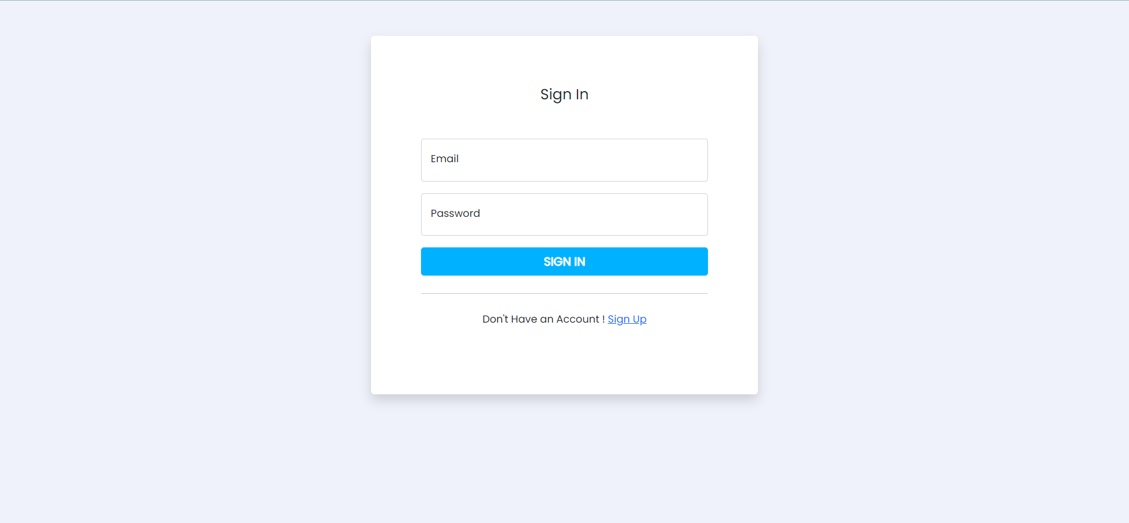

The login page allows a user to gain access to the application by entering their emailid and password . If the entered email id and password that are present in the IBM DB2 database it will allow the user to login to the dashboard otherwise it will shows the user error message that the entered email id or password is wrong. Then the user can able to enter the correct email-id and password.

**b. SignUp Page:**

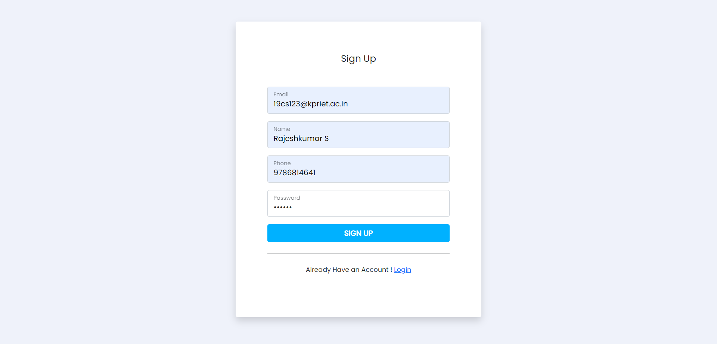

A signup page (also known as a registration page) enables users and organizations to independently register and gain access to your application. If the user is already present in the data base ie, the email id it ask us to go to the login page do login.

**c. Dashboard Page**

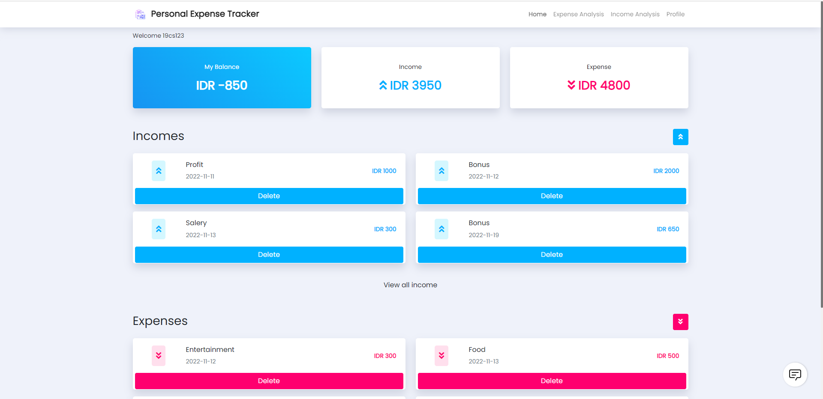

In this dashboard we can able to see the list of income and expense. As well as the total income, total expense also my Balance ie the difference between the total income and the total expense.

By clicking on that up arrow button we can able to enter the new income details. By clicking on that income card we can able to update the income details that we have entered earlier. Like this by using the down arrow button we can able to enter the expense details like date, note, category and also amount. By clicking on that expense card we can able to edit the expense details that are entered earlier.

**d. AddExpense Page:**

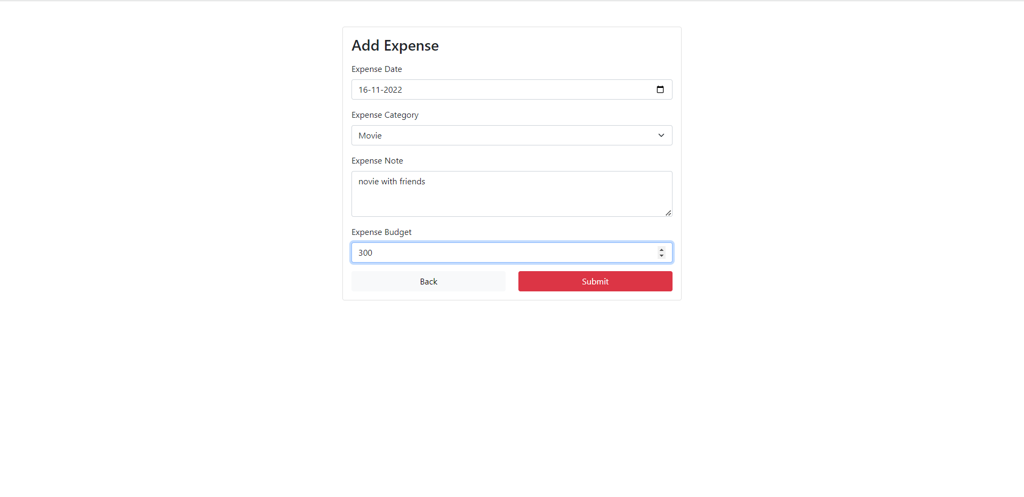

By this add expense page we can able to add the new expense to the table. We have to enter each and every details in the add expense page. Then click on the submit button we can able to commit the changes.

**e. Add Income Page:**

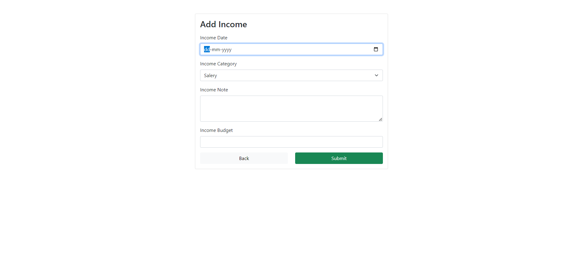

It was just like the add expense page once the all the values are enter d then after the submit button is clicked the datas will be saved in the income table .

**f. List Income Page:**

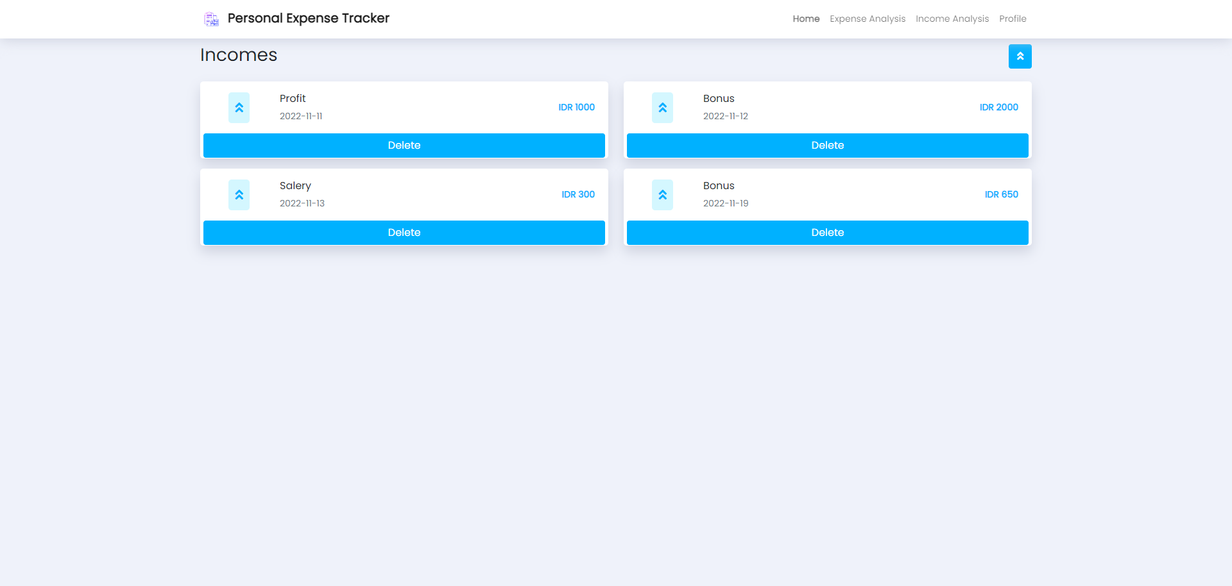

This page will add up and show incomes like profit,salaries,bonus that a person gets from the profit and bonus from salaries.This will show the total income that a person gained in that period of time like month,years.From the income person got he can make budgets for upcoming days.

**g. List Expense Page:**

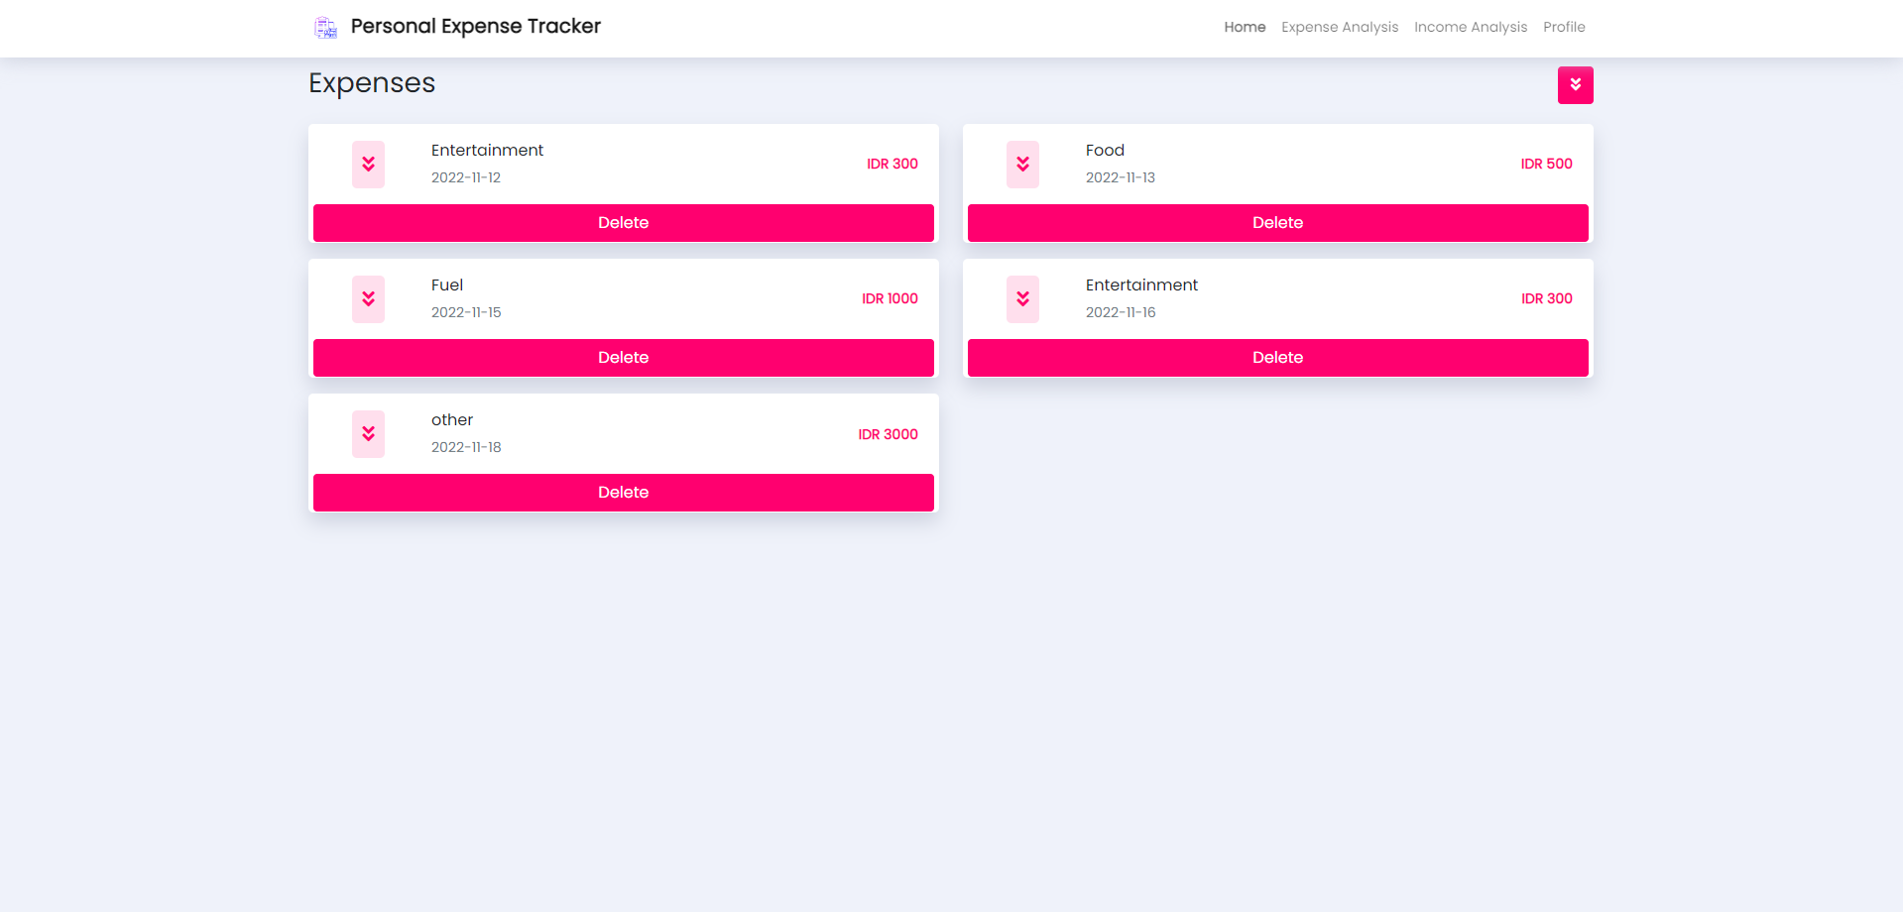

This page will list the expenses and helps to track the expenses that an individual made.This expenses Tracker helps the person to know the details in which the person has spend much on what commodities and helps to keep records.

**h. Income Analysis Page:**

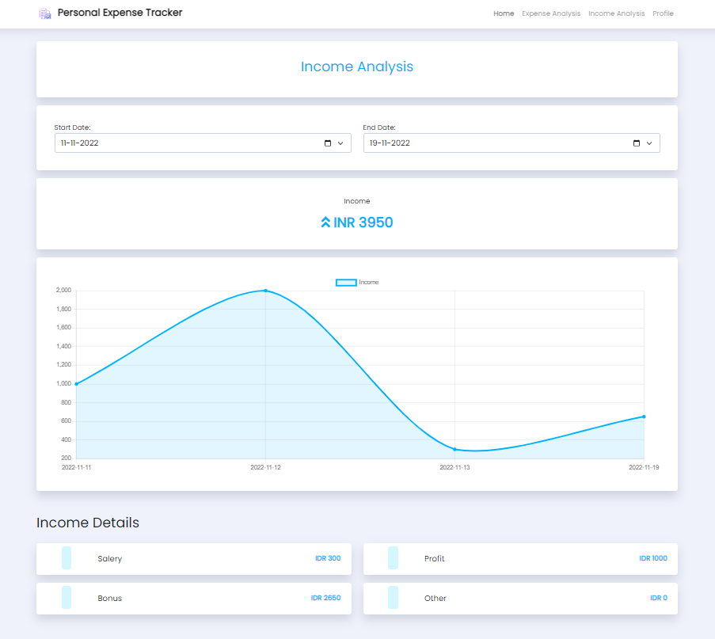

The Income analysis page helps the person to have an detailed graph shows the Profit,bonus and other kind of incomes that a person able to get and know from which time that that a person gains more profits and it will helps to keep track of incomes during peak times and dull times which helps to manage the expenses of the financial times.

**i. Expense Analysis Page:**

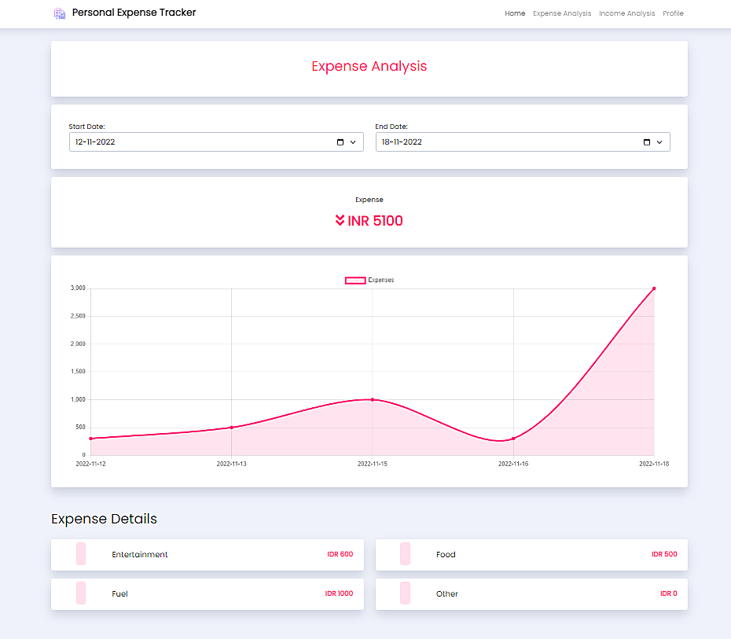

The Expenses analysis page helps the person to know the expenses that made on different times.The Analysis graph helps to know the expenses made on times with respect to the amount that a person spend.This will helps a person to track the expenses and able to control the expenditure that a person spends on things on particular times.

**j. Profile Page:**

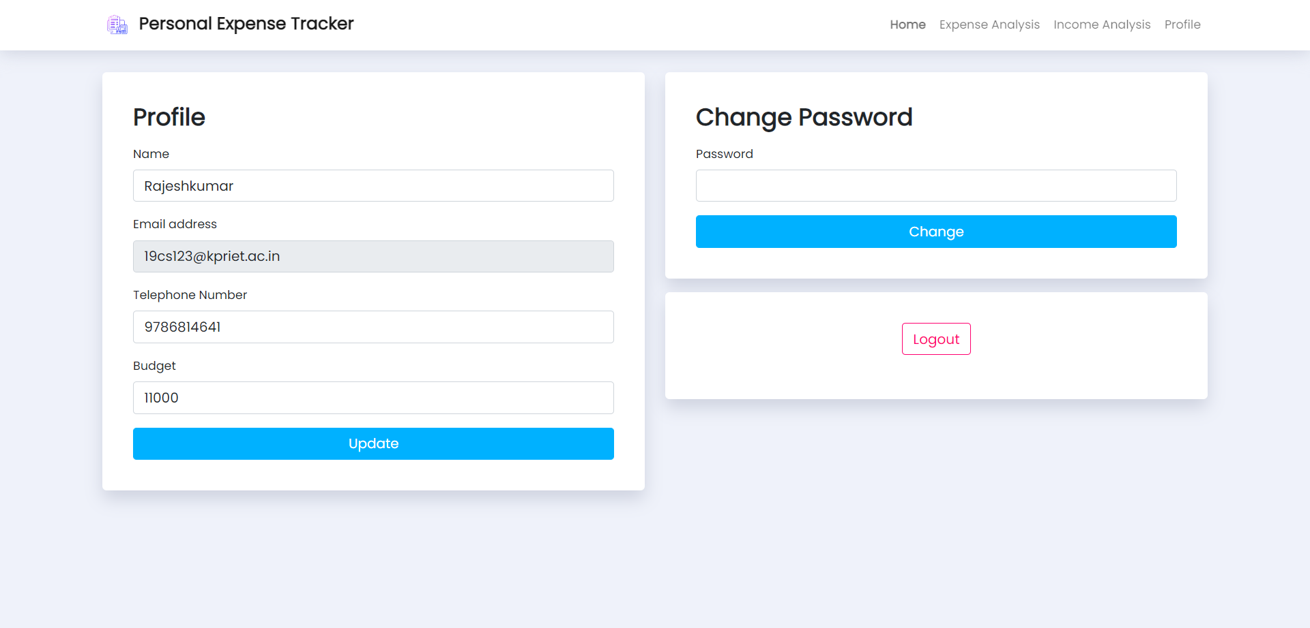

This Page is profile board for the user who create an account by adding his information which will be saved in the database and shown to the user as an profile dashboard module page where the user can see his/her Personal information which can be edited by clicking the update button the user can able to change the details that was given previously to new information updation.Also helps the user to update the password to secure his privacy by entering the current password and clicking in the change which direct to another page.

**10. ADVANTAGES & DISADVANTAGES**

**Advantages:**

* + 1. It is very easy to use and we can able to track the income and expense easily.
    2. We can able to Access it anywhere if you have the network connection.
    3. There is no need to afraid of loss of data.
    4. We can able to track the between the dates.
    5. We can able to set the budget. If the budget is over, it will alert the user by sending the mail to the user.

**Disadvantage:**

1. The Personal Expense Tracker works with the use of Internet without internet we cannot access the tracker which seems to be bit hardy.
2. The Budget will be included once in the month we cannot make any changes in middle .
3. The Analysis will be based on the One time budget

**11. CONCLUSION**

In conclusion, creating a personal budget and keeping track of all expenditures are critical components of personal finances. You should always have three months' worth of living expenses set up in a savings account, according to advice, in case of emergencies. Finally, every school should require a session on personal finance education for kids as early as possible. In order to teach their children about banking, credit cards, interest rates, and credit, parents must take the initiative. It was eye-opening to see how important it was to see my spending on my budget sheet actually. But now that I know where to cut the fat, I can boost the amount of money I have available for savings by modifying only a few things and eliminating others.

**12. FUTURE SCOPE**

* The personal expense tracker application is just used to track the expense and income. In future we like to improve the User Interface. The user interface (UI) can be improved in the future to accommodate a global audience by supporting multiple languages from different countries.
* In future we try to add the daily budget and weekly budget in our application to improve the user expense on daily basis or the weekly basis too.

**13. APPENDIX**

Source Code - <https://github.com/IBM-EPBL/IBM-Project-285-1658243423/tree/main/Final%20Deliverables>

GitHub - <https://github.com/IBM-EPBL/IBM-Project-285-1658243423>

Project Demo Link - <https://drive.google.com/file/d/1zsLUPf-Nqd0L1wDiGyrO5LuR34X_N9Qa/view?usp=share_link>